Table 2: Microphotographs and measured stoichiometry for (CuInSe₂)_{1-x} (TaSe)_{x} alloys with x = 0.1, 0.2, 0.3, 0.4 and 0.5. In red the nominal stoichiometry.
Microphotographs | Nominal Composition | Cu  at% | In  at% | Se  at% | Ta  at%
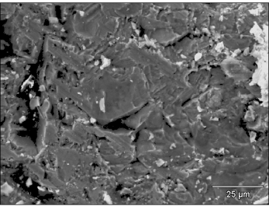 | x = 0.1 | 23.7 | 23.7 | 50.0 | 2.6
 | Exp. 1 | 22.7 | 17.7 | 58.8 | 0.8
 | Exp. 2 | 21.7 | 18.1 | 59.4 | 0.8
 | Exp. 3 | 22.1 | 18.4 | 58.3 | 1.2
 | Exp. 4 | 21.1 | 16.7 | 60.4 | 1.7
 | Exp. 5 | 21.9 | 17.8 | 59.2 | 1.2
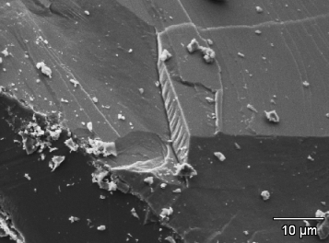 | X = 0.2 | 22.2 | 22.2 | 50.0 | 5.6
 | Exp. 1 | 20.2 | 18.1 | 59.1 | 2.5
 | Exp. 2 | 16.4 | 13.5 | 61.1 | 9.0
 | Exp. 3 | 16.4 | 12.5 | 62.1 | 9.0
 | Exp. 4 | 20.1 | 16.1 | 60.7 | 3.1
 | Exp. 5 | 20.2 | 17.1 | 59.9 | 2.8
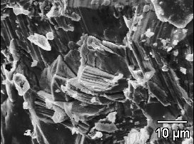 | X = 0.3 | 20.6 | 20.6 | 50.0 | 8.8
 | Exp. 1 | 16.8 | 12.5 | 60.2 | 10.5
 | Exp. 2 | 14.8 | 11.9 | 61.0 | 12.3
 | Exp. 3 | 22.3 | 15.6 | 53.2 | 8.7
 | Exp. 4 | 28.7 | 17.3 | 55.6 | 6.4
 | Exp. 5 | 20.7 | 14.4 | 57.5 | 9.5
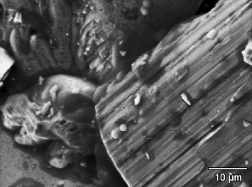 | X = 0.4 | 18.8 | 18.8 | 50.0 | 12.5
 | Exp. 1 | 12.5 | 19.5 | 54.6 | 12.5
 | Exp. 2 | 16.8 | 18.6 | 57.3 | 7.3
 | Exp. 3 | 17.3 | 20.1 | 57.6 | 5.0
 | Exp. 4 | 18.8 | 21.1 | 58.0 | 2.1
 | Exp. 5 | 16.7 | 19.8 | 56.9 | 6.7
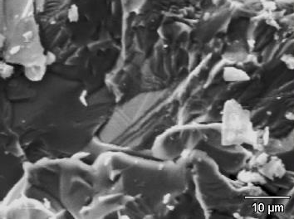 | X = 0.5 | 16.7 | 16.7 | 50.0 | 16.7
 | Exp. 1 | 11.8 | 3.6 | 65.6 | 19.1
 | Exp. 2 | 18.8 | 14.3 | 59.0 | 7.9
 | Exp. 3 | 21.3 | 13.2 | 61.3 | 4.3
 | Exp. 4 | 22.3 | 16.0 | 59.7 | 2.1
 | Exp. 5 | 20.8 | 14.5 | 60.1 | 4.6

